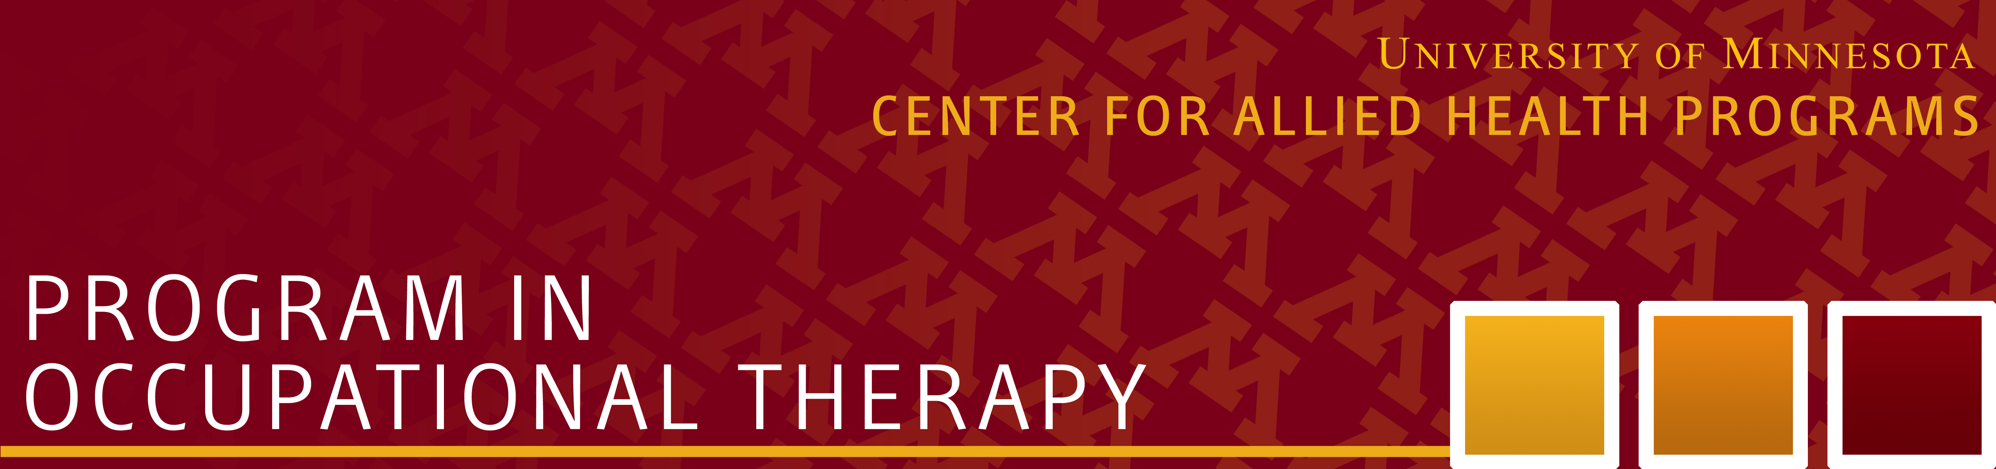

The University of Minnesota is seeking candidates for a part time Occupational Therapy (OT) Teaching Specialist position. Teaching specialists are practitioners who will support the instruction of individual courses, as laboratory instructors and/ or providing online instructional support. These appointments are short-term with typically small work effort percentages. We accept applications continuously throughout the year.

This single staff position has two possible campuses, Rochester or Twin Cities:

- Job ID 315275 Rochester campus
- Job ID 315276 Twin Cities campus

The Program in Occupational Therapy (OT) at the University of Minnesota is one of the oldest occupational therapy programs in the United States; having first prepared rehabilitation aids during the first World War. Since 1946 students have learned and practiced skills of occupational therapy in an accredited, occupational therapy program. Our rich history demonstrates our commitment to prepare outstanding occupational therapists. Faculty are committed to quality teaching using innovative approaches using blended online learning, experiential learning, public engagement, and supported research.

This is a part-time position based at the University of Minnesota Rochester or Twin Cities campus. Salary will be commensurate with credentials and experience. Employment is by semesters to specifically support portions of occupational therapy courses.

Required Qualifications:
• Practicing Occupational Therapist
• Completed master’s degree.
• Proficient in Microsoft word and web-based communication systems.
• Current Minnesota state license, or obtaining license within 3 months of hire as a condition of employment.
Desired Qualifications:
• History of teaching others (within higher education preferred).
• Experience using online learning platforms.

Diversity
The University recognizes and values the importance of diversity and inclusion in enriching the employment experience of its employees and in supporting the academic mission. The University is committed to attracting and retaining employees with varying identities and backgrounds.

The University of Minnesota provides equal access to and opportunity in its programs, facilities, and employment without regard to race, color, creed, religion, national origin, gender, age, marital status, disability, public assistance status, veteran status, sexual orientation, gender identity, or gender expression. To learn more about diversity at the U: http://diversity.umn.edu.

Background Check Information
Any offer of employment is contingent upon the successful completion of a background check. Our presumption is that prospective employees are eligible to work here. Criminal convictions do not automatically disqualify finalists from employment.

To Apply, complete the online application at: http://humanresources.umn.edu/jobs Position #315275 (Rochester) or #315276 (Twin Cities). Please provide a cover letter; curriculum vitae (CV); as well as the name and contact information of three professional references.

For inquiries, please contact:  John Nordstrom  Operations Manager  Center for Allied Health Programs  CAHPHR@umn.edu  877-334-2659 | Peggy M. Martin, PhD, OTR/L  Director, Occupational Therapy  marti370@umn.edu

Last updated May 1, 2018

